**NAME: OLAWUMI ABAYOMI EBENEZER**

**MATRIC NUMBER: EEE/12/9579**

**Chapter 12**

**Question 1(e)**

It expects a parameter of the year to check if it is leap or not

**Question 2 (a)**

There are 63 functions in the math module

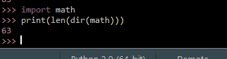

**Question 2(b)**

math.ceil approximates or round the float value to the nearest whole number

math.floor rounds a floating value down to the nearest integer

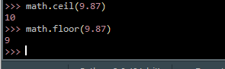

**Question 2(c)**

We have always been evaluating the square root of a number by raising it to the power of its fraction, a good example is shown in the figure below, the first line of code indicates the former way of doing it while the latter shows the new method.

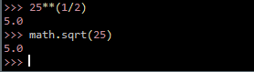

**Question 2(d)**

Two (2) data constants in math module – math.pi(pi) and math.e (Euler's number)

